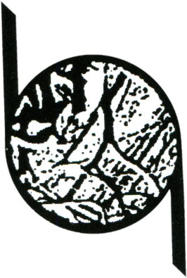 |  | Side A – obligatory filling
Participation card XVIII International Competition of Small Graphic Forms and Exlibris Ostrów Wielkopolski 2022

Participation card
18th International Competition of Small Graphic Forms and Bookplates
Ostrow Wielkopolski 2022
First Name
Surname
Address:
Street, house number
ZIP & Town / City
Country
Optional | E-mail / Phone
 | Website – www
 | I agree* |  | to publish my address in the catalogue of the XVIII Competition for Small Graphic Forms and Exlibris Ostrów Wielkopolski 2022
 | I do not agree*
(delete as appropriate; if no option is chosen, the address details will not be published)

No. | Exlibris / Graphic Title |  |  | Technique | Dimensions in mm  height / width |  | Year | To be completed by the organizer
I declare that I have read the Regulations of participation in the XVIII Competition of Small Graphic Forms and Exlibris. I agree to the terms of the regulations.
……………………………………………………………………………………………..
date and handwritten signature of the participant
 |  | Side B – optional filling
First Name and Surname |  |  |  |  |  | Gender
Date of Birth |  | Place of Birth / Nationality
Education
Participation in individual and group exhibitions
Prizes and awards

In accordance with Article 13, Regulation (EU) 2016/679 of the European Parliament and of the Council of 27 April 2016 on the protection of persons with regard to the processing of personal data and on the free movement of such data, and repealing Directive 95/46/EC (General Data Protection Regulation), I inform you that:
- The data controller is the Museum the city of Ostrów Wielkopolski, 63- 400 Ostrów Wielkopolski, Rynek 1, Tel: 62 592 80 52, e-mail: sekretariat@mmow.pl, website: http:/www.mmow.pl, BIP: https://muzeum.bip.gov.pl/.
- The data controller has appointed a personal data protection officer, with the location in the Museum city of Ostrów Wielkopolski, 63-400 Ostrów Wielkopolski, Rynek 1, tel: 62 592 80 52, e-mail: iod@kupijaj.pl.
- Personal data is collected and processed in order to carry out the implementation of the obligations of the data controller, with connection of the activities of the Statute of the Museum, on the basis of the article 6 paragraph 1, subparagraph a, b, c. - the person to whom the data apply – has given consent to the processing of his or her personal data, to fulfill contractual obligations with a data subject, processing is necessary to comply with a data controller's legal obligations.
- Personal data will be deleted within the time limits indicated in the Order of the Director of the Museum of the City of Ostrów Wielkopolski No. 1/2019 on the introduction of the office instruction, the single factual list of files and instruction on the organization and scope of operation of the company archive.
- The records may be made available to the supervisory authority on request.
- The person whose data are processed within the limits laid down by regulation has the right to: access his/her/ personal data; the removal of any item of datum or data; have any errors rectified; impose restrictions on the processing of their data; complain to the supervisory authority, namely the President of the Office for Personal Data Protection.

If you decide to exercise these rights, we may ask you to provide additional personal data in order to confirm your identity, thereby safeguarding against illegal access to your data by an unauthorized third party.

